CPE Working Mode
Version 1.0

(2017/5/1)
(Delivery team)

Summary

Document Control

Version | Date | Author(s) | Reviewer(s) | Status
1.0.0 | 2017/5/1 | Panda Xie |  | initial

Document References
Document Title | Version | Date | Remark

1.1 Mode Setting page
Below is the CPE web GUI. Firstly, we navigate ‘Network’->’Network Mode’ to enter network mode configuration page.
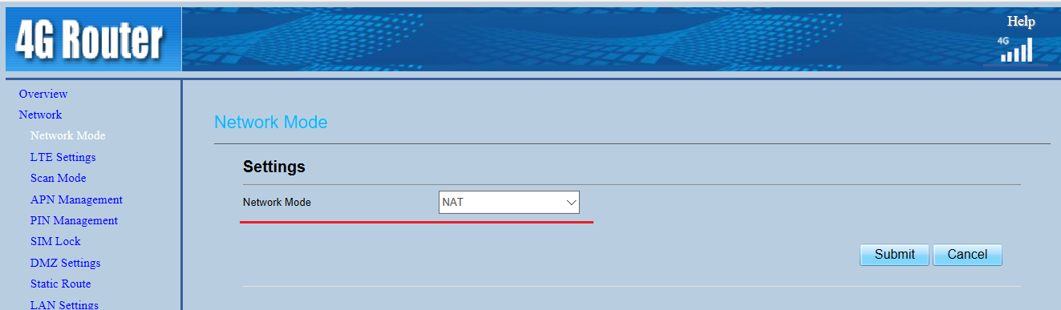
Network Mode: CPE have three modes,[NAT] ,[Router] and [Bridge], default value is [NAT].
Notice: Network Mode change need to power cycle to take effect. We advise you shouldn’t select Router mode regarding to stability and maturity.

1.2 Mode

1.2.1 NAT Mode
In NAT mode, CPE will change the private IP of user device to CPE WAN IP, user’s devices such as PCs and mobile phones connect to CPE through its LAN interface.

1.2.2 Bridge Mode
The CPE supports bridge mode in version MT-23425-1.2.3-R6-Standard (Outdoor CPE) or later. To configure bridge mode, referring to the following steps:
- Set the Network Mode as Bridge and submit, then the CPE will reboot automatically;
- After the CPE completes the reboot, configure a static IP which is in same subnet as CPE LAN IP used on your PC, then login into the web GUI, deselect the option as following figure:
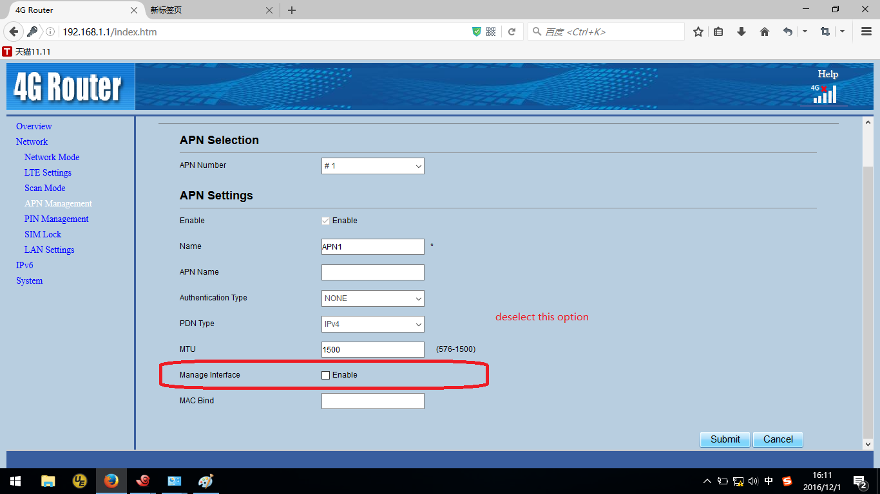
- Remove the static IP in your PC, just a moment later, your PC can get the IP allocated by the EPC.
In Bridge mode, the CPE will pass the IP address to the first device connected to LAN that does a DHCP request. Note that the IP will still be assigned by the cloud EPC. In bridge mode, you can still access the CPE via LAN if you statically configure the computer to be on the LAN IP subnet.

1.2.3 Router Mode
In Router mode, the CPE will forward all packets in Layer3 by using IP addresses and IP routes seem like a router.

